**Project Design Phase-II**

**Data Flow Diagram**

| Date | 17 October 2002 |
| --- | --- |
| Team ID | **PNT2022TMID49326** |
| Project Name | **Fertilizers Recommendation System For Disease Prediction** |
| Maximum Marks | 4 Marks |

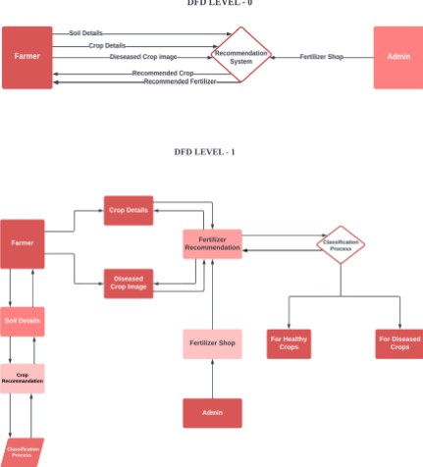

| **User Type** | **Function**  **al**  **Require**  **ment**  **(Epic)** | **User**  **Story**  **Numb**  **er** | **User Story / Task** | **Acceptance**  **criteria** | **Prior**  **ity** | **Release** |
| --- | --- | --- | --- | --- | --- | --- |
| **Customer**  **(Mobile**  **user)** | Registration | USN-1 | As a user, I can register for the  application by entering my email,  password, and | I can access  my account /  dashboard | High | **Sprint**  **1** |

**User Stories**

**Use the below template to list all the user stories for the product.**

|  |  |  | confirming my  password. |  |  |  |
| --- | --- | --- | --- | --- | --- | --- |
|  | Login | USN-2 | As a user, I can log into the application by entering email &  password | I can login  using my E  mail ID  accounts or  user  credentials | High | **Sprint**  **1** |
|  | Dashboard | USN-3 | As a user, I can view the page of the  application where i can upload my  images and the  fertilizer  should be  recommended | I can access  my account/  dashboard | High | **Sprint**  **2** |
| **Customer**  **(Webuser)** | Registration | USN-4 | As a user, I can login to web  dashboard just Like  website dashboard | I can register  using my  username and  password | High | **Sprint**  **3** |
|  | Login | USN-5 | As a user, I can login to my web  dashboard with the login  credentials | I can login using  my User  credentials | High | **Sprint**  **3** |
|  | Dashboard | USN-6 | As a user, I can view the web  application where i can upload my  images and the fertilizer  should be recommended | I can access  my account/  dashboard | High | **Sprint**  **4** |
|  |  | USN-7 | As a user, the fertilizer recommended  to me should be of higher  accuracy | I can access  my  account/  dashboard | High | **Sprint**  **4** |
| **Administrator** | Login | USN-8 | As a admin, I can login to the website  using my login credentials | I can login  to the  website  using my  login  credentials | High | **Sprint**  **5** |
|  | **Dashboard** | **USN-9** | **As a admin, I can view the**  **dashboard of the application** | **I can**  **access my**  **dashboard** | **High** | **Sprint**  **5** |